Using an Astrodon MonsterMOAG with a Takahashi FSQ-106N
Frank Barnes III http://www.skyimager.com
December 15, 2007

Taking guided CCD images with a telescope/camera combination presents unique challenges in every configuration. Some are easy to overcome, some not so easy. One goal of taking a good astro image is to produce round stars. When using one telescope/camera for taking the image, and another telescope/camera for guiding the imaging combo, movement between the two systems can cause stars to be elongated in the exposed image. Because the two telescopes can and usually do “flex”, (differential flexure) and have many places where this flex can occur, it can be hard to find and eliminate.

Another issue is guiding behind your filters. When using a SBIG dual chip camera, and imaging through the clear filter, your guide star may be bright enough for good guiding, but when the blue filter is used, the star may be too dim to guide on. It is even worse if using narrowband filters, as they attenuate the guide star many times more than the blue filter.

Every telescope has a certain amount of usable “Backfocus”, or the distance behind a defined spot on the telescope where the image plane (in focus point) exists. At that point, the camera chip needs to be perfectly square with the optical path to prevent distortion of the image. If your image train components are shorter than that distance, then the focus tube (refractor) will be extended to place the chip at the focus point. With today’s large chip cameras and even larger filter wheels, the weight that must be supported by that extended focus tube can easily top 8-10 lbs. This can cause the focus tube to “flex” as the telescope tracks across the sky and this can cause the chip to become tilted on the optical plane resulting in distorted stars especially in the corners of the chip. Here is an example of focuser “sag” as I rotated my camera through 180 degrees. Note the changing collimation and curvature numbers in the top left corners.

Images taken at the “0” degree PA (Position Angle)

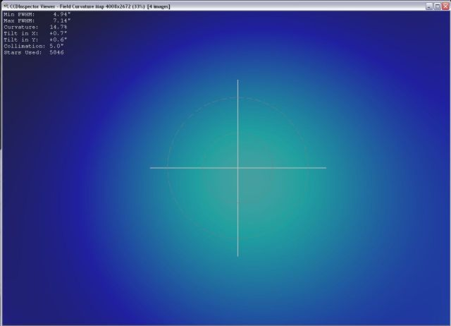

Images taken at “90” degrees PA

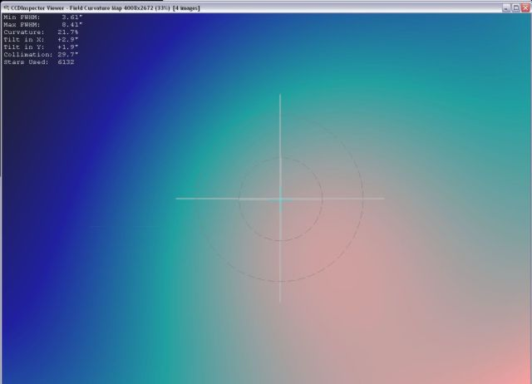

Images taken at “180” degree PA

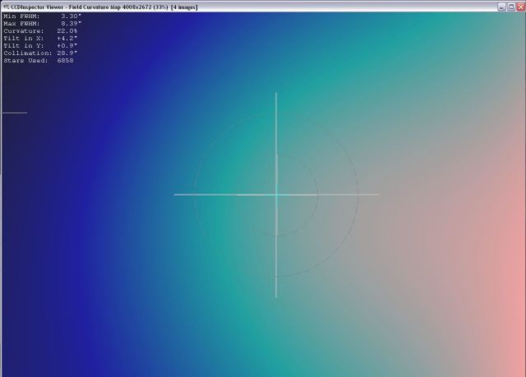

These are averages of 4 images each taken one after the other, at the same RA/DEC, and processed in CCD Inspector. The focuser sag follows the heavy side of the camera/filter wheel.

One approach to eliminating that “flex” or sag, and the filter issue at the same time, is to use an Off-Axis Guider (OAG) and guide on the same optical path as the main telescope/camera is using, and guide in front of the filters.

The Takahashi FSQ-106N has 120mm (4.72”) of backfocus as measured from the camera/eyepiece side of the Camera Angle Adjuster (CAA). A Camera/filter wheel combo will easily fit inside this distance. I wanted to use an OAG to eliminate the flexure component and filter issue, but most that I found were rather long and had a small diameter opening that would vignette the larger chips. After adding up all the distances for adapters to get between the different thread sizes, the total length of the image train would not fit within the backfocus requirement. An important requirement for an OAG to work properly is that the distance from the main imaging chip to the OAG pickoff mirror or prism, must be equal to the distance from the pickoff mirror or prism to the guider chip. Many OAGs have the distance from the pickoff mirror to the top guider port fixed and quite long. This uses up the backfocus of the FSQ and prevents the cameras from reaching focus.
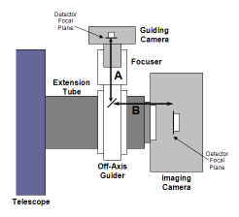

Then I talked to Don Goldman at AIC about his newly designed MonsterMOAG (OAG). It has a large 65mm opening to accommodate the current large chip cameras, and is only 1.25” thick, so it takes of very little of the precious backfocus distance. It also has a changeable guider port so you can shorten the pickoff mirror/prism to guide chip distance as well. Don has adapters for many telescope/camera connections, allowing the MonsterMOAG to be used with a variety of equipment. More information on the MonsterMOAG can be found on Don’s website:

http://www.astrodon.com/documentation/documentation.cfm?DocID=13

Now that I had all the components to guide and image in front of my filters and not be concerned with differential flexure, I turned my attention to eliminating all the remaining places where movement/sag can affect the tilt of the camera on the focal plane. The two remaining locations that can cause shifting on the image plane are the 4” focuser and the CAA. With the weight of the larger cameras and filter wheels, the focus tube has more stress placed on it, and it can move since it was probably adjusted for an eyepiece weight. I found my focuser to be quite loose and that needed to be eliminated. One way to check to see if your focuser is loose, is with the camera/filter wheel removed and the focus tube extended to about 3/4 of the full focus travel, hold the CAA in one hand and try and gently move it up and down, and side to side. If you feel any movement, you could probably benefit from an adjustment. I talked with Fred at Texas Nautical and he gave instructions on how to do just that. The following is how I made my adjustments based on his instructions:

- Remove the focuser lock to expose the 4 setscrews.

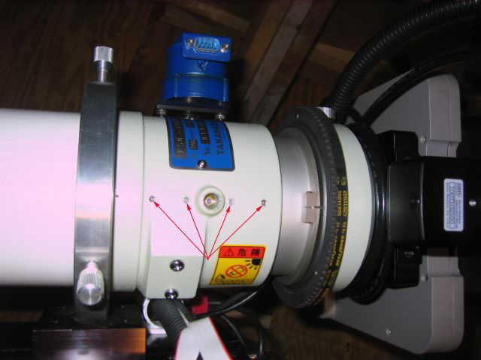

- Use a 5/16 Allen wrench to make the adjustments.
- Takahashi uses a glue to seal over the top of the setscrew, so to get the allen wrench to go in, you need to put a drop or two of acetone on each setscrew to dissolve the glue.
- Start by tightening the front most setscrew (closest to front of FSQ) first. As little as a 16th of a turn may be all you need.
- Then move to the rearmost setscrew and tighten it the same amount.
- Check the focuser for smooth, non binding movement, then re-check the focuser for movement by performing the up/down, side to side test.
- If it all feels nice and tight with no play, then tighten the two inner setscrews the same amount as the front and back and recheck the focuser for a smooth, non binding, or sticking movement.
- You are now done and the focuser should be nice and tight and not move under the weight of the camera/filter wheel.

The second place that can shift and cause the camera to tilt on the image plane is the CAA. If it loose, you will be able to feel it move when the camera/filter wheel is installed. It is very easy to adjust out and can be done per the following:

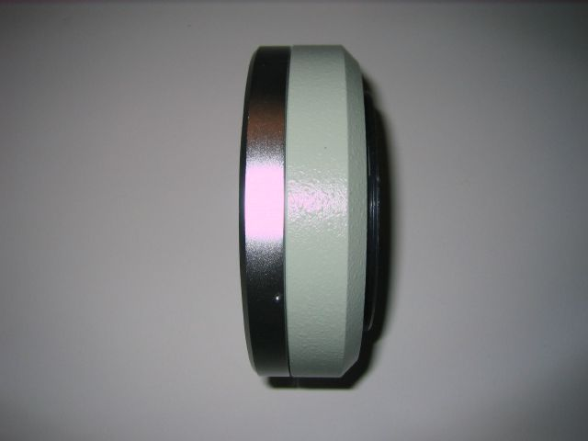

- If you suspect or feel any looseness in your CAA, first remove it from the telescope by tightening the rotator lock and then unscrewing it off the scope.
- After you have it off, loosen the rotator lock and place your thumb on the outside of the CAA and your fingers on the inside (the part that rotates).
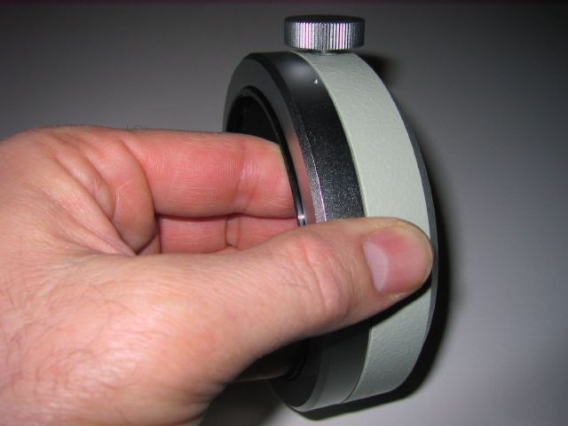
- Move your fingers in and out to feel the play that may be there.
- To adjust the play out of the CAA, you will need a 0.035” allen wrench. These are not usually included in the standard Allen wrench set, so I ordered a small set from Wiha Quality Tools – http://www.wihatools.com/ part # 26399
- There are three (3) 0.035” hex setscrews in the silver retaining ring of the CAA. Loosen them all with the hex wrench.

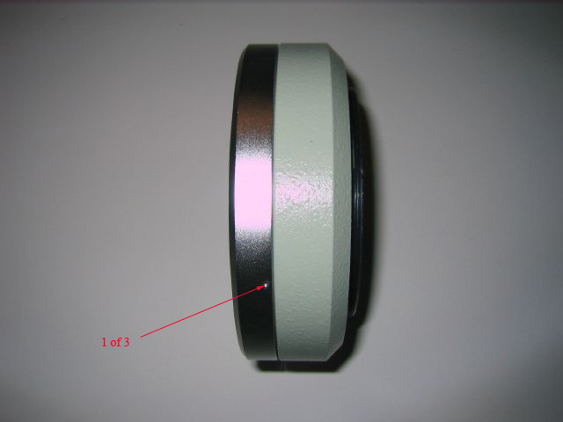

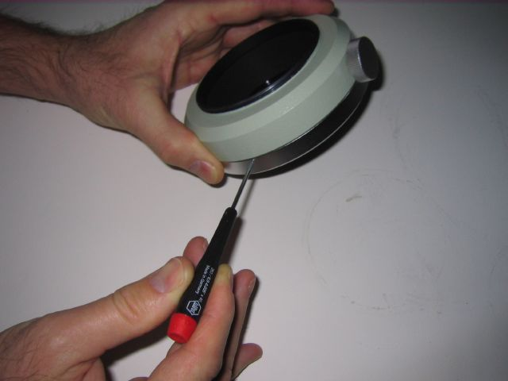

- After all three setscrews have been loosened, the silver retaining ring will rotate, as it is just screwed on to the CAA. When tightened, it applies additional pressure to the inside spindle that rotates, removing the play. Tighten and check the rotation for binding. If you can’t rotate the inner spindle at all with your fingers, then you probably have it too tight. Back off the silver retaining ring just a small amount until the rotation is smooth, but the play is gone. Then retighten the 3 set screws and you are done.

- The following pictures show removal of the retaining ring and the disassembled 4 parts of the CAA.

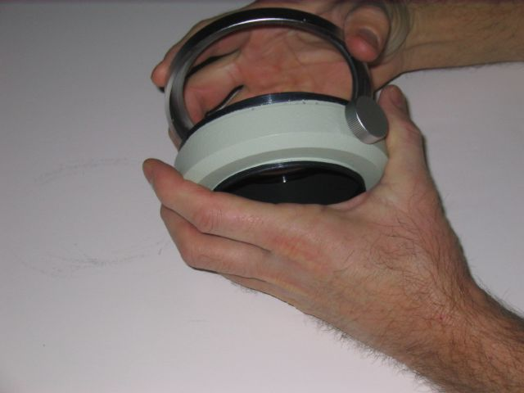

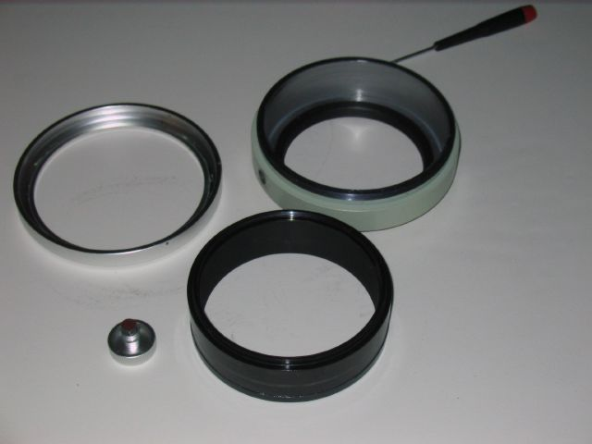

Now that all the parts that could cause unwanted tilt have been tightened, it is time to re-assemble the FSQ image train and add the MonsterMOAG.

I image with a SBIG STL-11000XM and a SBIG FW8 filter wheel. While not the largest chip out there, still a good size and the STL-11000/FW8 is a heavy payload. To minimize the backfocus taken up by the MMOAG, two adapters were fabricated for the STL-MMOAG-CAA connection that only takes up 0.675”. One screws into the front adapter plate of the FW8 filter wheel and then attaches to the MMOAG. The second connects the MMOAG directly to the CAA. The addition of the MonsterMOAG (MMOAG), plus adapters and camera/filter wheel, take up all but about 0.662” of the 4.72” backfocus distance. (Measured distances in the chart below) I use a Robofocus on my FSQ and that requires no additional backfocus. The 0.662” of focus travel accounts for about 2600 steps on my Robofocus. This is plenty, to accommodate changes due to temperature swings, and still allows enough travel to “train the focuser” by running V-curves with FocusMax. The MMOAG is the perfect solution for my guiding needs. It all fits into the 120mm backfocus limitation of my FSQ-106N, and I have no flexure at all. The addition of Don Goldman’s Takometer for automated rotation completes my fully remote controlled imaging setup.

 |  |  | Mechanical
 | Equipment |  | Back Focus
 |  |  | Distance (in)
1 | SLT-11K |  | 1.559
2 | FW8 |  | 0.350
3 | STL-MMOAG Adapter |  | 0.055
4 | MMOAG |  | 1.228
5 | MMOAG-CAA Adapter |  | 0.620
6 | Takometer |  | 0.250
 | Total from back of CAA |  | 4.052
 | 120mm BF converted to inches |  | 4.724
 | Backfocus available |  | 0.662

The MMOAG is very easy to install as it uses 4 setscrews for attaching each adapter. After I installed the MMOAG, I used a square to place the guiding camera 180 degrees from the internal guidechip of the STL-11K. This makes it easier to create your FOVI in TheSky6 for finding guidestars.

Here are a few images of all the parts assembled and ready to be remounted, and a screen capture of my FOVI from TheSky6. I also included a couple of views of how it looks as it sits on my 16” RCOS truss. If you are trying to solve a flexure issue, need long guided exposures for narrowband imaging, or are just considering adding a guidescope to your setup, then here is an alternative worth considering.

A close-up that shows how little backfocus the adapters take up.

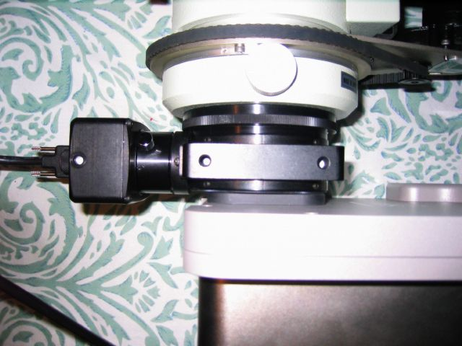

Here is a picture of all the parts assembled and ready to be installed on the mount.

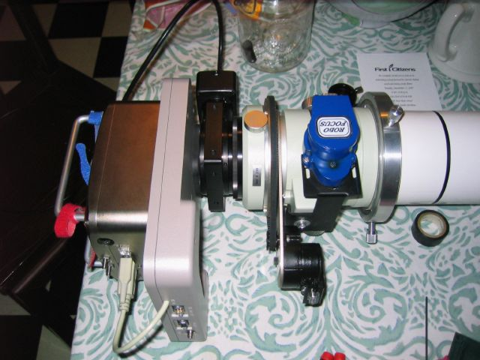

Here is the FSQ back on the mount having just finished a focus run. Note that there is an adequate amount of focus tube travel remaining to handle temperature changes and stay in focus.

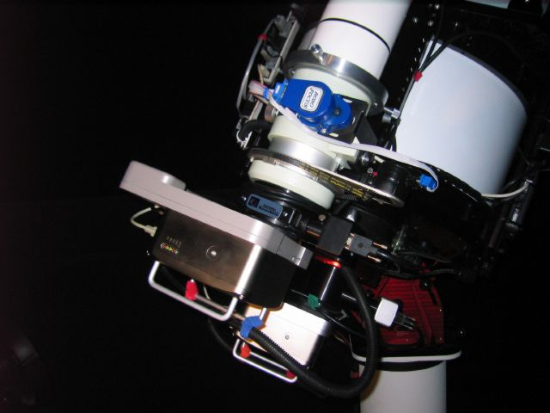

This makes for a very tight, compact and rigid imaging package.

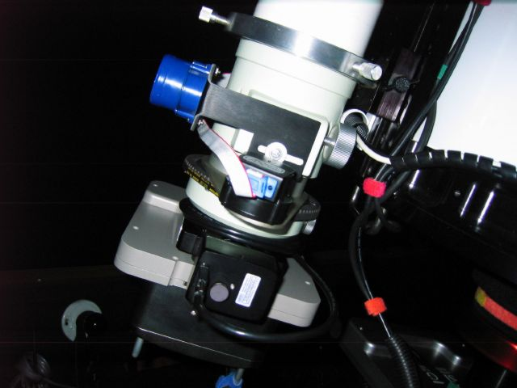

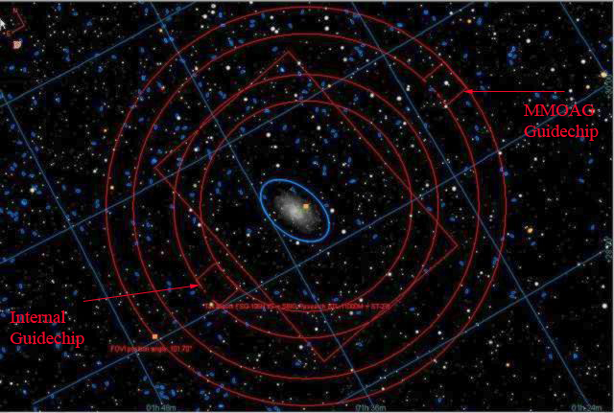

Using the MMOAG with a rotator allows you to easily frame your target and find the perfect guide star, as you now have complete control of all aspects of the imaging equipment. Here is an example of one of my autoguider logs after the MMOAG installation. The two red blocks to the right of the center point on the left hand chart were the dither staring point and the first correction. After that, you can see the RMS and peak to peak values that were produced under less than pristine skies. The guiding is now more stable and the camera stays square to the optical plane at all rotational angles. This has worked out to be the perfect solution to my remote imaging needs.

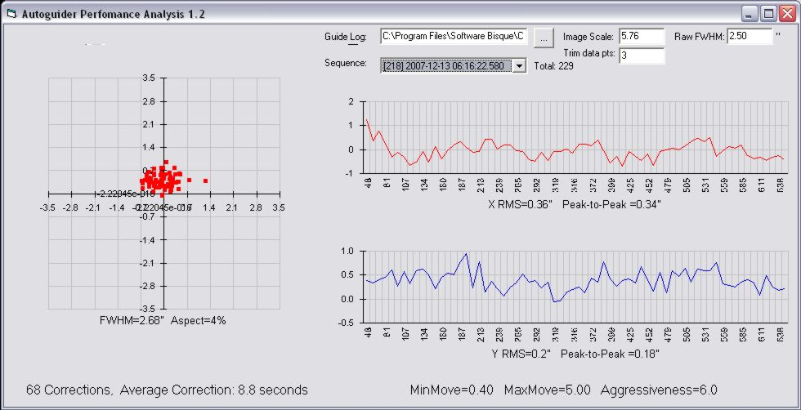

The first image that I took with this new setup was an Ha shot of IC405 and IC410. The image is located on my website here: http://www.skyimager.com/imagedata/IC405-IC410_12-18-07.html

