Application Note
Using the Advanced Menu to Set the Camera Configuration
November 15, 2005

Purpose
This Application Note describes how to access and use the commands in the Advanced Menu to reset the camera configuration information. This information is stored in the camera in a nonvolatile EEPROM and on rare occasion has been corrupted and requires re-initialization. If your camera has forgotten what model camera it is, say it’s supposed to be an ST-8 but it thinks it’s an ST-7, then this Application Note is for you.

The Advanced Menu
CCDOps has an Advanced menu that has commands that we hide from the casual users to avoid confusion. To access this Advanced menu you need to make a special shortcut to CCDOps using the following:
- Create a shortcut on your Desktop to CCDOps. This is done by right-clicking the mouse on the Desktop and selecting New -> Shortcut. You’ll have to find CCDOps on your hard drive and note that typically CCDOps is installed in the C:\Program Files\SBIG\CCDOps5 directory.
- Once the Shortcut has been created, right-click on the shortcut then select the Properties command.
- Add ‘ /advanced’ to the end of the Target field. Add it with the leading space and without the single quotes but after the existing closing double quote. In the end your Target field will look like:
"C:\Program Files\SBIG\CCDOps5\Ccdops.exe" /advanced
- Run CCDOps by double-clicking on the new shortcut. After the Intro dialog goes away you should see the Advanced menu to the right of the Help menu.

The Camera Configuration Command
Establish a link to your camera and then use the Camera Configuration command in the Advanced menu. You’ll be presented with the dialog shown below:

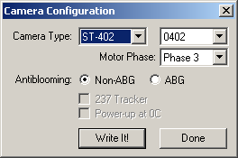

Each of the items is discussed individually below:
Camera Type Select the model and sub-model of your camera using these two pop-ups. The STL and ST-402 have sub models and the other cameras do not.
Motor Phase For the ST-402 model cameras, select one of the four possible motor phases. For the other cameras you don’t need to worry about this.
You can tell which motor phase is correct by trying each one and then seeing which one causes the filter to be centered over the CCD for light frames
Antiblooming Some model cameras can come with ABG detectors or Non-ABG detectors. Set this accordingly.
237 Tracker Check this item if your self-guided camera has a TC-237 guiding CCD in it. Older model USB cameras used the TC-211 for the tracking CCD. For those cameras leave this unchecked.
Power Up at 0C Normally you will leave this unchecked. Checking it causes your camera to cool to 0C automatically at power up. Some customer asked for this so we put it in there.

Set each of these items accordingly and then click the Write It! Button to send it to the camera. If everything works right you should get a message reminding you to power down the camera and power it back up again. This is critical as many of these settings only get recognized at power-up.

Setting the CCD Offset
USB Based cameras also retain CCD Offsets in the nonvolatile EEEPROM and this may need to be reset as well. If your dark images are all black and the crosshairs shown 0 counts in the image this is the problem. Fixing this is accomplished with the Set USB Offset command in the Advanced menu which is shown below:

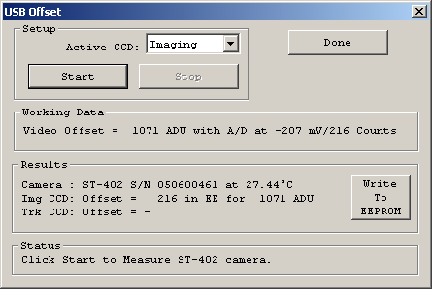

To use this command, make sure the camera is in the dark with the nosepiece cover in place and then select the Imaging CCD as the active CCD then click Start. In a few seconds the process will finish and the results will be displayed as shown in the figure above. At this point of your camera has a Tracking CCD then select it and repeat the process. Finally, click the Write to EEPROM button to save the results in the camera. Reboot the camera and verify that dark and light images are as you would expect.

