The Advanced Menu
CCDOps has an Advanced menu that has commands that we hide from the casual users to avoid confusion. To access this Advanced menu you need to make a special shortcut to CCDOps using the following:
- Create a shortcut on your Desktop to CCDOps. This is done by right-clicking the mouse on the Desktop and selecting New -> Shortcut. You’ll have to find CCDOps on your hard drive and note that typically CCDOps is installed in the C:\Program Files\SBIG\CCDOps5 directory.
- Once the Shortcut has been created, right-click on the shortcut then select the Properties command.
- Add ‘ /advanced’ to the end of the Target field. Add it with the leading space and without the single quotes but after the existing closing double quote. In the end your Target field will look like:
"C:\Program Files\SBIG\CCDOps5\Ccdops.exe" /advanced
- Run CCDOps by double-clicking on the new shortcut. After the Intro dialog goes away you should see the Advanced menu to the right of the Help menu.
Adjust shutter

1. Rotate Shutter and check for dragging
2. Index Shutter Blade
a. Establish Com Link
b. Select Energize ST-L Shutter from Advanced drop down menu.
c. Loosen 2-56 Hex Nut Rotate Shutter Blade to position flag slightly to the right of optical sensor. Figure 3
e. Tighten Nut while holding Blade

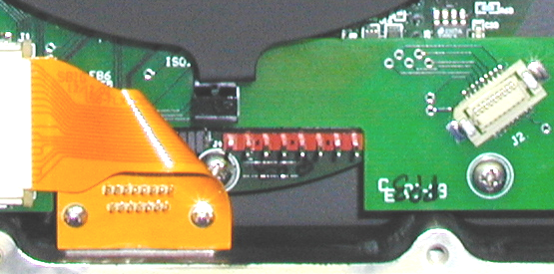

Figure 3

24. Attach Top Cover Assembly using (8) 4-40 X ½ SHCS SS. Be sure to align J1 on
optical Sensor Board with J2 on Accessory Board

